### ****TECHMART SALES ANALYSIS REPORT****

#### ****Objective****

The aim of the analysis is to identify customer purchasing behavior, product performance, sales and regional trends to make informed decisions for improving sales and customer satisfaction.

### ****Key Findings and Insights****

#### ****1. Customer Analysis****

**A. Top Cities with Unique Customers**

* The top 5 cities with the highest number of unique customers were identified as New York, Houston, Chicago, Phoenix, and Los Angeles, indicating cities with strong customer bases.
* **Insight**: Focus marketing campaigns in high-customer-density cities to maximize reach.

1. **Age Group with the Highest Spending**

* The **26–35 age group** spends the most on average.
* **Insight**: Tailor promotions, discounts, and products for this age group to boost sales.

#### ****2. Product Analysis****

**A. Top 5 Most Frequently Purchased Products**

* The top-selling products were identified as Product5, Product9, Product8, Product2, and Product20, reflecting customer preferences.
* **Insight**: Ensure adequate stock of these products and prioritize them in advertisements.

**B. Total Sales by Product Category**

* **Furniture** emerged as the category generating the most revenue.
* **Insight**: Stock up new furniture and run targeted promotions.

#### ****3. Sales Performance****

**A. Monthly Sales Trends**

* Sales peaked in **December**, likely due to holiday shopping and in **March**, probably after rebound from settling in the new year.
* **Insight**: Plan promotional campaigns and inventory stock ahead of the holiday season to meet demand.

**B. Highest Revenue Store**

* Store8 consistently generated the highest revenue, indicating strong customer loyalty and sales efficiency.
* **Insight**: Use this store's strategies as a benchmark for other locations.

#### ****4. Regional Trends****

**A. Regional Sales Comparison**

* The **West region** accounted for the largest share of total sales.
* **Insight**: Allocate more resources to this region, such as opening new stores or marketing efforts, to maintain momentum.

**B. Highest Average Sale Value by Region**

* The **West region** had the highest average sale value per transaction.
* **Insight**: Investigate factors contributing to higher-value purchases in this region and replicate these strategies elsewhere.

#### ****5. Customer Loyalty****

**A. Customers Making Purchases Every Month**

* No customer made purchases every month.
* **Insight**: However, loyalty offers or exclusive discounts can be created to reward and retain frequent buyers.

**B. Percentage of Repeat Customers**

* **97% of customers** were repeat buyers.
* **Insight**: Focus on converting one-time buyers into repeat customers through targeted email campaigns, special offers, and excellent customer post-sale service.

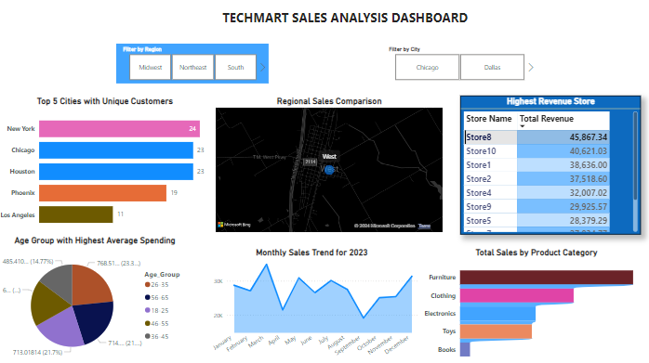

### ****Rationale Behind Queries****

* **Data Cleaning**: Ensured accurate analysis by removing invalid records and standardizing values.
* **WHERE and Comparison Operators**: Filtered relevant data for specific time periods, regions, or customer behaviors.
* **JOINS**: Combined multiple datasets to reveal relationships between customers, products, stores, and sales.
* **GROUP BY and Aggregates**: Summarized data to calculate totals, averages, and trends.
* **Views**: Created reusable query results for easier reporting and analysis.

### ****Recommendations****

1. Allocate resources strategically to high-performing regions and age groups to maximize returns.
2. Leverage peak sales months for revenue growth.
3. Analyze the success of high-revenue stores and replicate strategies.
4. Offer loyalty rewards to frequent buyers.
5. Promote top-selling products in under-performing regions.
6. Restock high-demand products in regions with higher sales.